Westlaw Access

After clicking through to Westlaw from OpenAthens you should be able to login if you follow these steps:

At this screen select Westlaw UK (old platform)

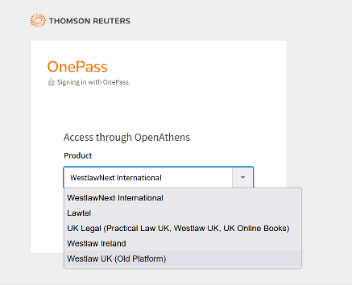

Then select Access through OpenAthens on the next page:

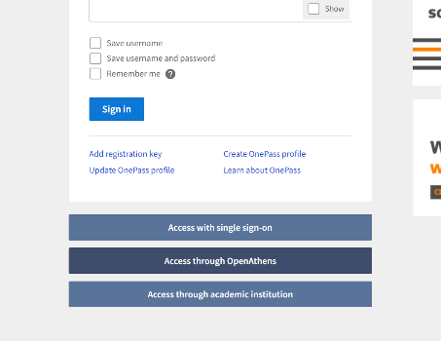

This should sign you in to Westlaw.

[Last updated: 10/10/2024]

